- Radio Frequency
We will be using ASK (Amplitude Shift Keying) based Tx/Rx (transmitter/receiver) pair operating at 433 MHz. The transmitter module accepts serial data at a maximum of XX baud rate. It can be directly interfaced with a microcontroller or can be used in remote control applications with the help of encoder/decoder ICs. The encoder IC takes in parallel data which is to be transmitted, packages it into serial format and then transmits it with the help of the RF transmitter module. At the receiver end the decoder IC receives the signal via the RF receiver module, decodes the serial data and reproduces the original data in the parallel format.
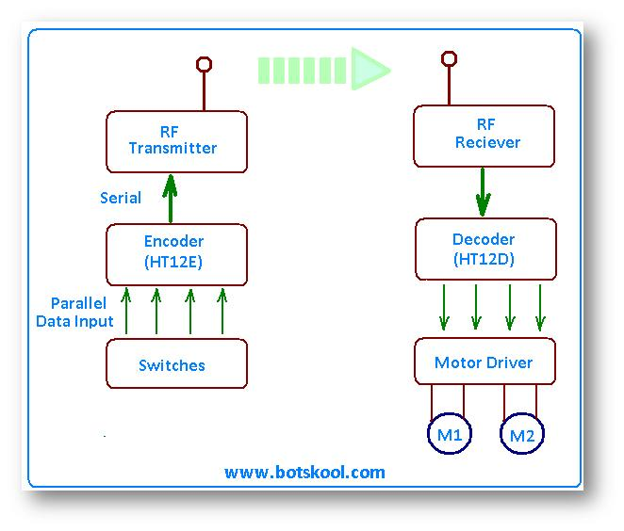
The schematic is as shown below.
